Logical view of the system

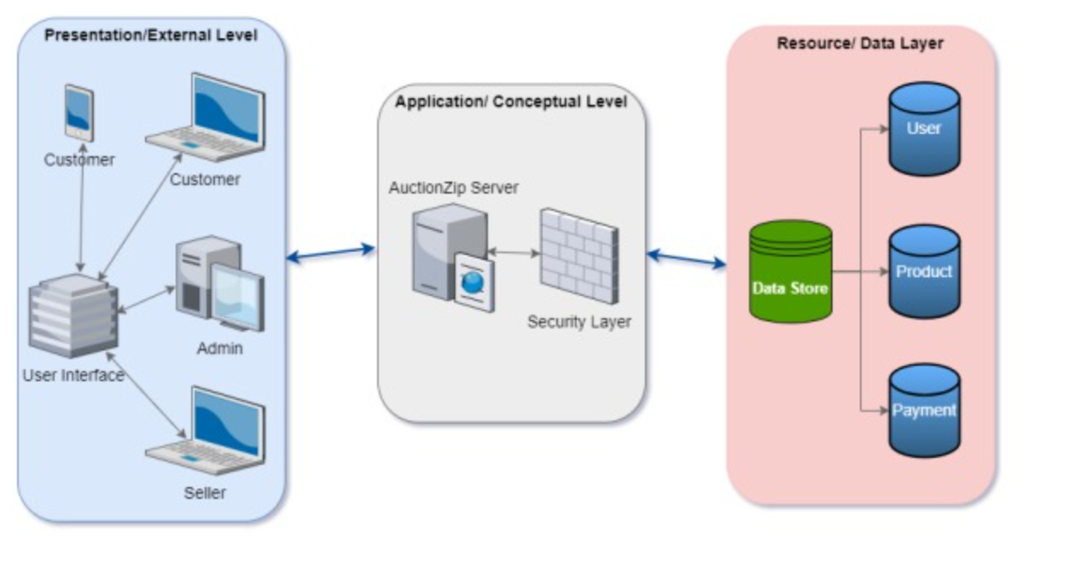

Fig. Logical view of auctionzip online system.

The above diagram shows how the users can create their account according to their purpose in presentation layer. The users can generate their request in presentation layer and the request is immediately transferred to application level. In application layer, we have auctionzip server which runs our website where data is fetched from the resource layer that is required in manipulation. Auctionzip server has code, required files to run website and it relates to the SQL database. The response is created in application layer and appeared in presentation layer. Now the users can access the result in the front end.